End of Life Options Act
of Colorado
and DNA 4 / DNA 6 meeting
Presenters:
Dr. Jennifer Harbert and Helen Lester, RN, MSN

Saturday, October 7, 2017 from 10:00 – 1:30
at the First Methodist Church
2005 Mullins Ave., Alamosa
Join us as we have a presentation followed by discussion of Colorado’s End of Life Options Act. What does it state, and what are the implications for implementation?
DNA 4 /DNA 6 meeting from 11:15- 1:30 includes further discussion, lunch and meeting.
Lunch - $6.00
RSVP to Charlotte Ledonne by Wednesday, October 4th

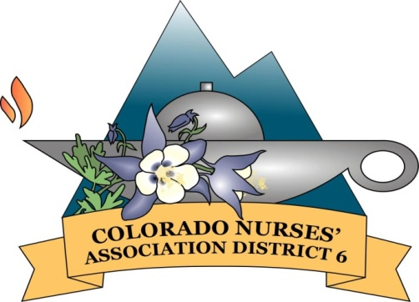
Sponsored by Colorado Nurses Association, District 6 and
Women's Citizenship Club of Alamosa

